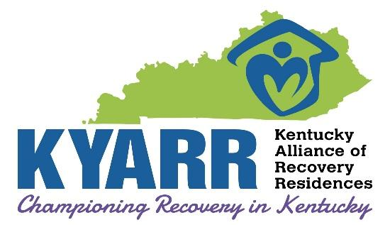
Recovery Housing Grievance Form
The Kentucky Alliance of Recovery Residences (KYARR) expects all those with a complaint or grievance with a certified recovery house or its staff/volunteers should first attempt to resolve the situation at the local level per the KYARR/NARR certification required grievance process. KYARR understands that in some instances this may not be possible. In such cases and where local attempts to resolve the situation have not been successful, a grievance may be submitted to KYARR by completing and submitting this form.

YOUR NAME: |  | EMAIL ADDRESS:
LANDLINE PHONE: |  | MOBILE PHONE# FOR TEXT OR CALL:
MAILING ADDRESS:
CITY: |  |  | STATE: |  | ZIP CODE:
NAME OF KYARR CERTIFIED RECOVERY  HOUSE FOR WHICH GRIEVANCES IS ASSOCIATED: | ADDRESS OF RECOVERY HOME: |  |  | CITY, STATE AND ZIP CODE;
 | IS THERE A SPECIFIC STAFF OR VOLUNTEER WHO IS THE SUBJECT OF THIS GRIEVANCE? |  |  | IF YES, PLEASE PROVIDE THE NAME OF THE INDIVIDUAL:
 | □ YES □ NO
Please provide a full description of the event/circumstances: (Attach additional pages if necessary)
Please provide what you reasonably believe should be done to resolve this situation to your satisfaction:
Please email the completed form to: info@kyarr.org
Mail to: KYARR Recovery Housing Grievance
8911 Greeneway Commons Place, Suite 101
Louisville, KY 40220

