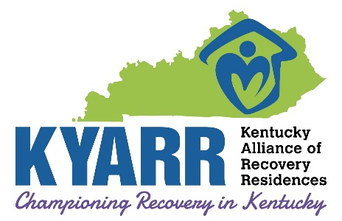

Recovery Housing Grievance Policy

Recovery Housing Grievance Policy

- The Kentucky Alliance of Recovery Residences, KYARR, recognizes the importance of a formalized complaint resolution and grievance process. This process supports recovery and helps to better ensure equitable treatment of all residents and accountability for all certified recovery houses in Kentucky.

- KYARR encourages all complaints and grievances to be addressed at the lowest and most direct level possible. Concerns or complaints may be addressed either informally or formally.

- KYARR requires each certified recovery residence to have its own grievance policy to resolve issues within the recovery community if possible. Further, KYARR requires all certified recovery homes to advise all residents at orientation of their rights and how to file a grievance. All recovery homes must make grievance complaint forms available to their residents.

- Those attempting to resolve a concern or complaint should not be threatened, penalized nor have services negatively affected or otherwise be retaliated against as a result of filing a grievance or complaint.

- Residents of a certified KYARR Recovery House, if dissatisfied with the grievance resolution obtained through the recovery housing grievance process, have a right to file a written appeal of their grievance resolution to KYARR, as outlined in the following procedure. In addition, issues that concern the direct health, safety and welfare of residents should be filed directly with KYARR.

- Neighbors, community members and other stakeholders of certified KYARR Recovery Houses who have a legitimate issue with the operations or conduct of a certified house may file a complaint with KYARR.

- Per 908 KAR 1:410, an applicant for certification dissatisfied by a decision of the cabinet, or certifying agency, may submit a request for reconsideration, in writing, to the commissioner for the department, or designee, within ten (10) days following notice of the decision.

Recovery Housing Grievance Procedure

- If a resident or interested party is unable to obtain or is dissatisfied with the resolution of a grievance or complaint with a KYARR certified recovery house or KYARR recovery housing staff or volunteer, a grievance may be submitted to KYARR for review by the KYARR staff and/or Board of Directors.

- All questions, concerns, and allegations will be properly addressed in a timely manner commensurate with the level of accusation reported, not to exceed ten working days from the time the complaint is received.

- This complaint must be submitted to KYARR in writing and mailed or emailed to the address below or as listed on the KYARR website: www.kyarr.org

- If KYARR does not resolve your grievance to your satisfaction, you may submit an appeal to the KYARR Board of Directors within ten working days from the time you receive the KYARR written resolution of the matter. This appeal must be written and mailed or emailed to:
  - KYARR, Attn: Executive Director
  - 8911 Greeneway Commons Place, Suite 101
  - Louisville, KY 40220
  - info@kyarr.org

- The decision made by the KYARR Board of Directors shall be the final decision for KYARR.

- Outcome Notifications - Written grievances are considered formal complaints and must be handled with written responses. Even when verbal meetings are held, KYARR’s final response will always be in writing. Complaints/Grievances that are addressed verbally are considered informal and will receive a verbal response. Any informal grievance may advance to a formal grievance at the discretion of the individual or agency making the grievance.

- Communications – A grievance form is located on KYARR’s website; www.kyarr.org. It is the desire of the KYARR Board of Directors that concerns and/or grievances can be addressed and resolved in good faith and cooperation between all parties involved.

I have read and understand the KYARR grievance policy and procedures listed above.

__________________________________________ ___________________________________________ _______________

Signature of Agency Representative Printed Name Date

